7 Day Task Update
DAY 1:

DAY 2 :

TOPICS I LEARN : CREATE DATABASE, SHOW DATABASES, USE DATABASE, CREATE TABLE, ALTER TABLE (DROP COLUMN), PRIMARY KEY, AUTO_INCREMENT, FOREIGN KEY, REFERENCES, INT, VARCHAR, DECIMAL, NOT NULL, DEFAULT, INSERT INTO, SELECT, INNER JOIN, ONE-TO-MANY RELATIONSHIP, WHERE, IN OPERATOR, SUBQUERY, MAX, MIN, SUM, GROUP BY, ORDER BY DESC

SUMMARY : I CREATED THREE TABLES CALLED CAKES, CUSTOMERS, AND ORDERS, AND CONNECTED THEM SUCH THAT THE ORDERS TABLE IS LINKED TO BOTH THE CAKES AND CUSTOMERS TABLES USING PRIMARY AND FOREIGN KEYS. THEN, I PERFORMED SEVERAL QUERIES ON THESE TABLES.
QUERY I DID IT :
- Highest & lowest priced cake
- Orders with valid customers and cakes (using INNER JOIN)
- Cake-wise total quantity sold
- Most sold cake (using ORDER BY DESC)
- Customer + cake + quantity details
- Filter by specific cake names

CAKES ORDERS CUSTOMERS

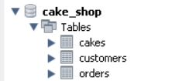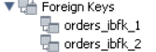

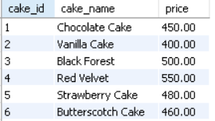
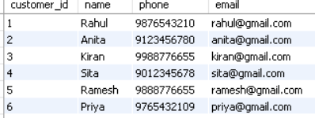
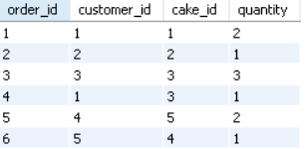

Max AND MIN PRICE CAKES
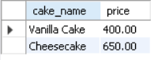

SPECIFIC CAKE NAME WITH QUANTITY WITH CUSTOMER DETAILS
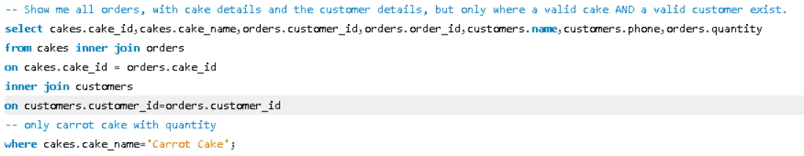
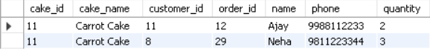

TOTAL QUANTITY SELLS WITH CAKES NAME WHICH SELLS THE MOST THAT Y I USED ORDER BY IN DESCENDING

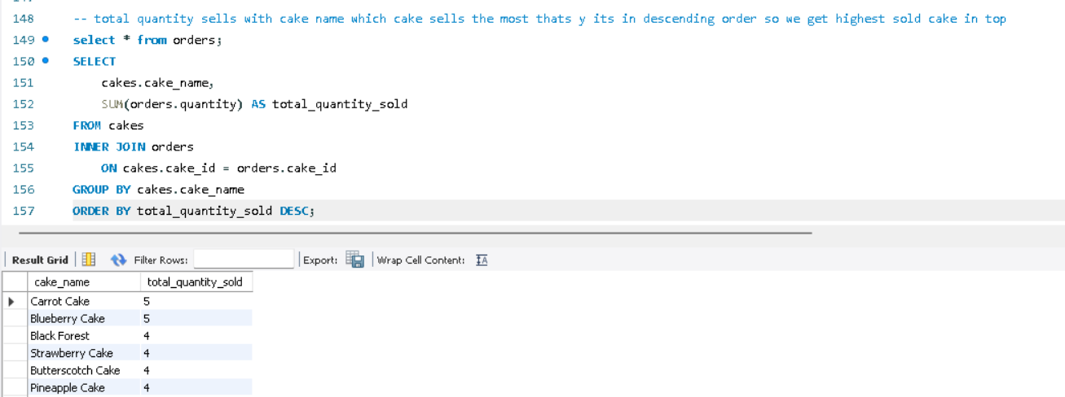

ONLY MENTION CAKES WITH CUSTOMER DETAILS AND QUANTITY
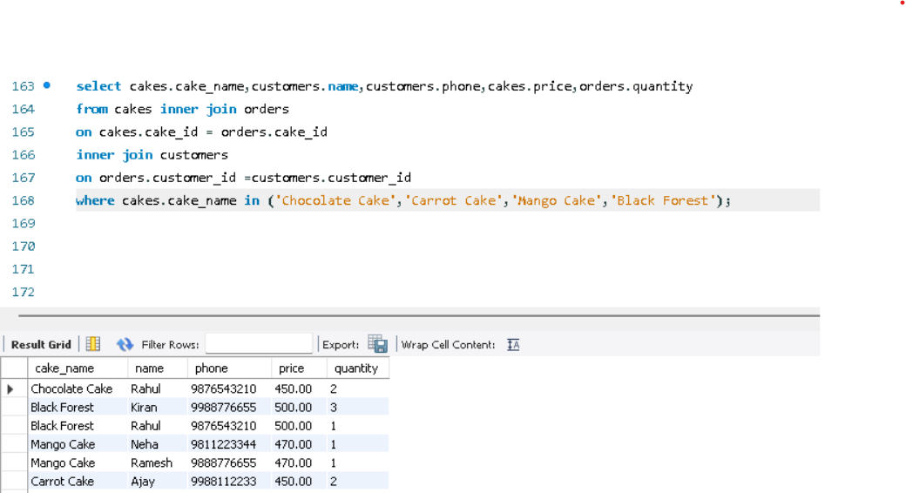

DAY 3 DATA CLEANING WITH PYTHON :
IN MY DAY 3 TASK I PREFER TO USE VSCODE FOR PYTHON BASICS AND DATA CLEANING. TO RECAP BASICS , THE YOUTUBE CHANNELS LIKE BRO CODE I REVISED FROM THIS CHANNEL AND WEBSITE I USED IS W3SCHOOL AND I USE AI CHATGPT FOR NEEDED STAFF

SUMMARY : Imported CSV data using pandas, inspected dataset structure using head(), info(), and describe(), identified missing values and fake NA entries, converted object columns to proper numeric and datetime data types, handled missing values using median and cleaned and standardized text columns, removed duplicates, fixed invalid and inconsistent values, validated the cleaned dataset, and finally exported the cleaned data .

Before :
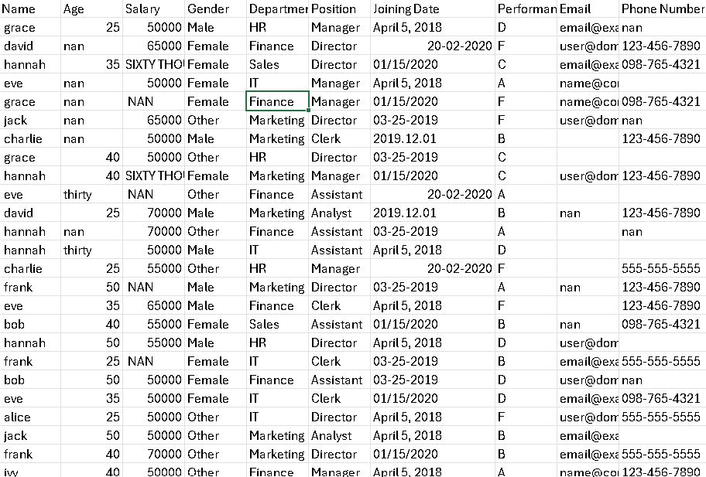
After : Cleaned Dataset Exported After cleaning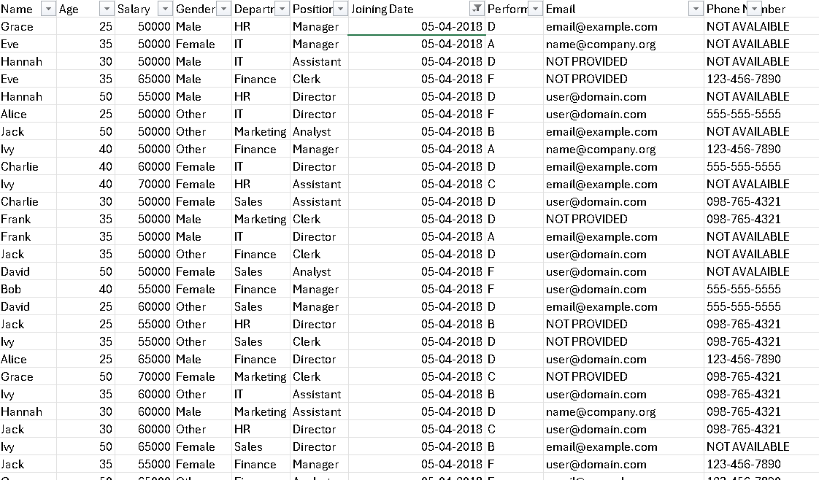
First I Check Columns Each Columns Info Like Its Data types, null values , its standardize or not , any extra spaces . after I Checked columns info replace Age , Salary Columns na values to Median of that column and change text value which is present in age and salary Column into Numeric values and Change Its data types
Age Salary Email these columns have missing values

Imported the CSV using pandas and inspected the dataset to identify missing values and wrong data types.
Cleaned fake NA values, converted object columns (Age, Salary, Date) to proper numeric and datetime types, and filled missing values using median.
Standardized text fields, validated the final dataset, and exported the cleaned data.

DAY 4 : Visualization with Tableau
Imported the cleaned HR dataset into Tableau and removed unnecessary columns. Created individual worksheets to visualize employee count by department, gender distribution using a pie chart, average salary by department, performance score distribution, and age group histogram using bins. Then combined all charts into a single interactive dashboard using containers. Added filters for department and gender to enable dynamic analysis. Finally, formatted and titled the dashboard for clear presentation of HR insights.

The dataset I used here that messy Hr dataset only which I used for cleaning so that cleaned dataset I used here for Dashboard
names of all charts which I created :
- Employees by Department (Bar Chart)
- Gender Distribution (Pie Chart)
- Average Salary by Department (Bar Chart)
- Performance Score Distribution (Bar Chart)
- Age Distribution (Histogram)
After This all Charts I Created a Dashboard Combining this all 5 charts
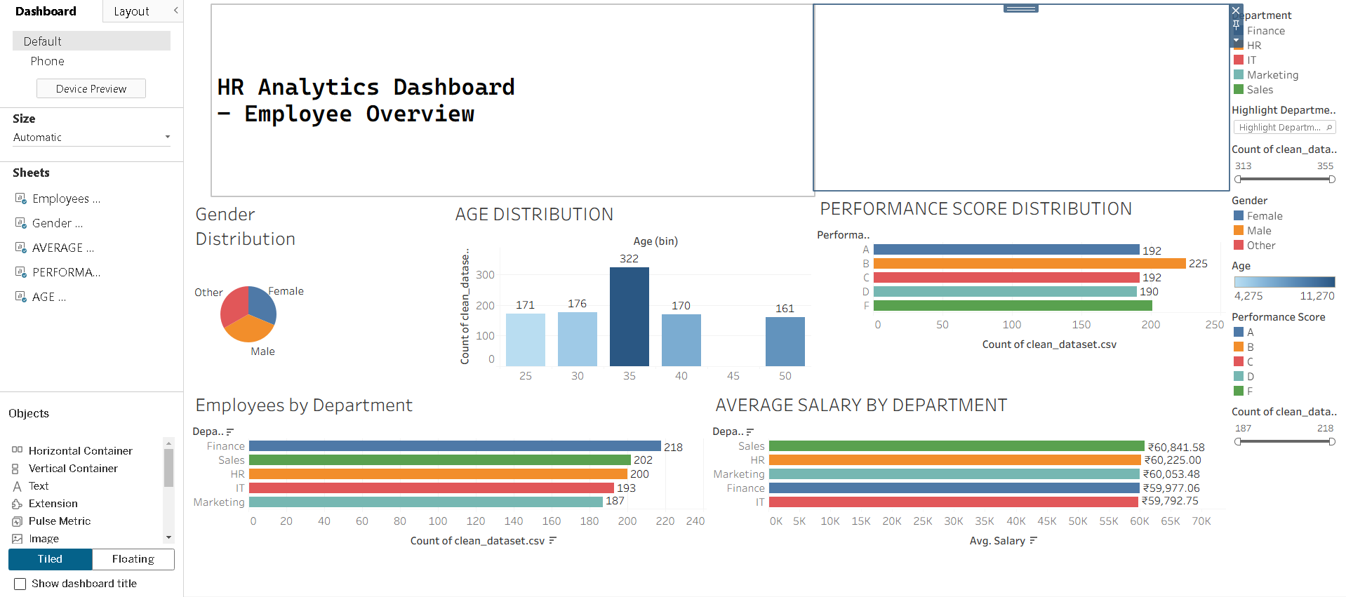

DAY 5 : Statistical Analysis
1. Descriptive Statistic
Statistics is the foundation of data science. Descriptive statistics are simple tools that help us understand and summarize data. They show the basic features of a dataset, like the average, highest and lowest values and how spread out the numbers are. It's the first step in making sense of information.
Topics Inside Descriptive Statistic : - Types of Data , Measure Of Central Tendency(Mean , Median ,Mode ),Measure Of Position ,Shape of Data Distribution , Frequency Distribution , Data Visualization .

- Types of Data – 2 Types of Data
Qualitative( categorical ) And Quantitative (Numerical Data)
In this there are one more sub division there
Quantitative Have 2 More Types : Nominal( NO Order) and Ordinal(Order)

Example :
Nominal : Color ( Red , yellow , green ) it’s a qualitative Data(Categoircal) in this There is No order or sequence it store randomly

Ordinal : Rating (Poor < Avg < Good < Excellent ) in this there is a order or sequence like better or have higher values then previous

Where we use : Customers Segmentation , Survey Analysis

Why we use Mainly Because If we Have Many Categorical Columns first we need to Encode them in Binary Language And Machine will Understand that category

Quantitative (Numerical Data)
In this there are 2 sub-divisions:

Discrete Data (Countable Numbers) :
Example:
Number of students = 45
Number of orders = 10
Number of calls = 120
Here values are always in whole numbers, not in decimals.
There is a fixed count and you cannot divide it into smaller parts.

Continuous Data (Measurable Numbers) :
Example:
Weight = 62.5 kg
Height = 170.3 cm
Time = 5.75 minutes
Temperature = 36.6°C
It is quantitative (numerical) data and it is measurable.
Here values can be in decimals and can take any value in a range.
There is no fixed count, values can increase or decrease smoothly.

Qualitative (Categorical)
- Nominal → No order (Color, City)
- Ordinal → Has order (Ratings, Levels)

Quantitative (Numerical)
- Discrete → Countable (No. of students, Orders)
- Continuous → Measurable (Height, Salary, Time)

- Measures of Central Tendency
The three main measures of central tendency are
1. Mean (Average) :
Sum of all values ÷ Number of values
Example:
Salaries: 10k, 12k, 15k, 18k, 2,00,000
Mean = (10k + 12k + 15k + 18k + 200k) / 5 = 51k
Problem:
Most people earn around 10k–18k,
but mean shows 51k, which is misleading because of one very high value (outlier).
Where we use Mean:
- Exam scores (when no extreme values)
- Sensor data (temperature, speed)
- When data is normally distributed
2.Median (Middle Value) :
Middle value after sorting the data
Example:
Salaries: 10k, 12k, 15k, 18k, 2,00,000
Median = 15k
Why better here:
It shows what most people actually earn,
outlier doesn’t affect it.

Where we use Median:
- Salary analysis
- House prices
- Income reports

3. Mode (Most Frequent Value) :
Value that appears most times

Example:
T-shirt sizes: M, L, M, S, M, L
Mode = M

Works for:
- Categorical data also
- Finding most common choice
Where we use Mode:
- Product size demand
- Most sold item
- Survey answers

Measures of Dispersion (Spread of Data) :
It tells how much the data is spread out, not just the center.
Because two datasets can have same mean but totally different behavior.

Example:
Class A marks:
50, 50, 50, 50, 50 → Mean = 50
Class B marks:
10, 30, 50, 70, 90 → Mean = 50
Mean is same, but:
- Class A → all students same level
- Class B → big difference between students
So we need spread measurement → that is dispersion.

- Range :
Highest value − Lowest value

Example:
Marks: 20, 40, 60, 80
Range = 80 − 20 = 60

Like 60 we got a point where students are spread across 60 marks gap

- Small range → less dispersion (data close)
- Large range → more dispersion (data spread out)
But Range Alone is NOT Enough
Let’s see two datasets:
Dataset A:
20, 40, 60, 80
Range = 60
Dataset B:
20, 21, 22, 23, 80
Range = 60
Both have same range = 60
But:
- Dataset A → values spread evenly
- Dataset B → most values near 20, only one big outlier
So dispersion is very different, but range can’t show that.
That’s why range is called a rough / weak measure of dispersion.

- Variance : Variance measures the average squared distance of each data point from the mean and indicates how widely the data is spread around the average.

Variance = average of
(each value − mean)²

Class B Marks:
10, 30, 50, 70, 90
Mean = 50

Mean = 50
Student mark = 10
So:
(10 − 50) = −40
This means:
That student is 40 marks below the class average.
So the distance from average = 40 marks.

Why Variance Feels Weird
Because:
- Unit becomes marks²
- Not directly meaningful

Standard Deviation = √Variance

What is Data Distribution?
It shows how data values are spread across a range.
Skewness — Shape of the Data (Left or Right Lean)
Skewness tells which side data is stretched more.

1.Right Skewed (Positive Skew)
Most values are small, few are very large.
2. Left Skewed (Negative Skew)
Most values are large, few are very small.
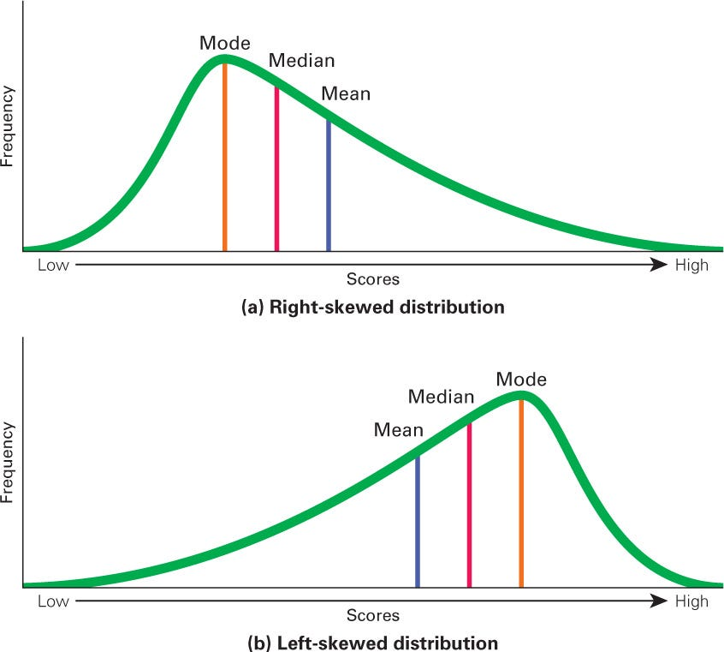

Kurtosis — Peaked or Flat Data
Kurtosis tells how sharp or flat the peak is and how heavy the tails are.
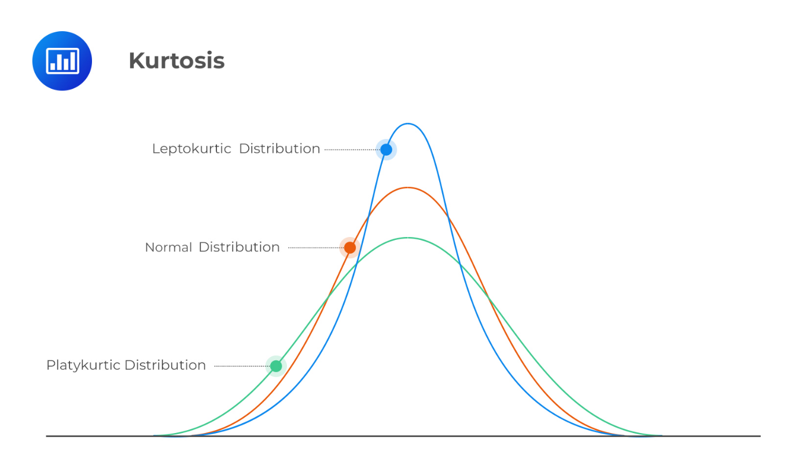

What is Frequency Distribution?
It shows how many times each value (or range) appears.

Data Visualization

What you want | Use This
Compare categories | Bar chart
See trend over time | Line chart
See % share | Pie / Donut
See distribution | Histogram
Relationship between 2 numbers | Scatter
Find outliers | Box plot

Hypothesis Testing (Simple Meaning)
It is a method to check if a claim about data is true or not using sample data.

Example:
Company says:
“Average delivery time is 30 minutes.”
You test with real data to see:
Is this true or not?

Two Types of Hypothesis
- Null Hypothesis (H₀): No change / no difference / claim is true
- Alternative Hypothesis (H₁): There is a change / difference

p-value (Very Important)
- Meaning:
p-value = probability that the result happened by chance assuming H₀ is true.
Decision Rule:
- p ≤ 0.05 → Reject H₀ (result is significant)
- p > 0.05 → Fail to reject H₀ (not enough proof)

Types of t-test
🔹 1. One-sample t-test
Compare sample mean with known value.
Example:
Is average battery life = 10 hours?

🔹 2. Independent t-test
Compare means of two different groups.
Example:
Boys vs Girls marks

🔹 3. Paired t-test (Before / After)
Compare same group before and after.
Example:
Weight before diet vs after diet

Practical:
Applied statistical concepts by performing an independent t-test using Python (SciPy) on an HR dataset to compare average salaries between IT and HR departments. Selected relevant columns, filtered required groups, computed the t-statistic and p-value, and interpreted the result to determine whether the salary difference was statistically significant.
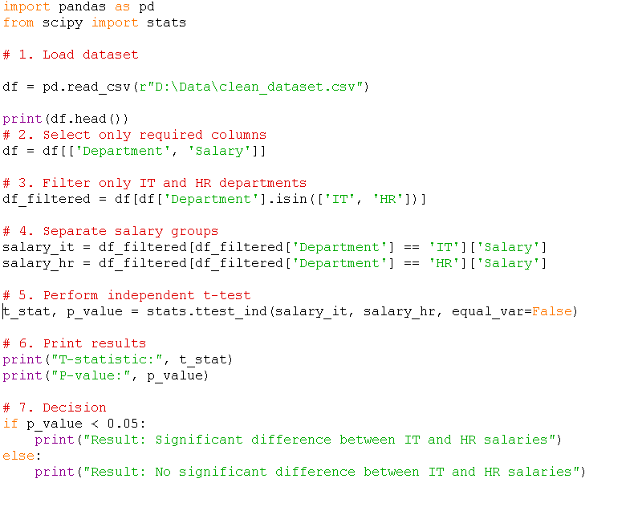

Output :
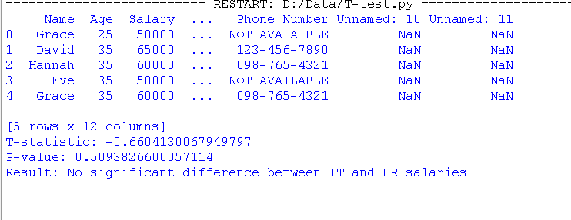

Day 6: A/B Testing :

A/B TESTING CONCEPTS :
What is A/B Testing?
A method to compare two versions (Version A = control, Version B = variant) to see which gives better results.

Example:
- Website Button A vs Button B
- Old UI vs New UI
- Email Subject A vs Subject B
Control Group & Test Group
- Control Group (A): Original version
- Test Group (B): New or changed version
Users are randomly divided into these two groups.

Key Metrics (What We Measure)
Depends on problem, such as:
- Conversion rate
- Click-through rate
- Purchase rate
- Time spent
Hypothesis in A/B Testing
- H₀ (Null Hypothesis): No difference between A and B
- H₁ (Alternative Hypothesis): B performs better than A

• Null Hypothesis (H₀): No change / no difference / claim is true
• Alternative Hypothesis (H₁): There is a change / difference

What is t-statistic (t-stat)?
🔹 Simple meaning:
t-stat tells how far your sample result is from the expected value, in terms of variation.
In easy words:
t-stat = “How strong is the difference?”
- Small t-stat → difference is small → maybe just luck
- Big t-stat → difference is large → likely real difference

Real-World Example: New Teaching Method

Situation:
School introduces a new teaching method.
Old average marks = 60
After new method, they test 20 students and get:
New average = 70
Now question is:
Is this improvement real, or did it happen just by chance?

t-stat checks:
How big is the difference (70 vs 60) compared to normal variation in marks?
t-stat = strength of improvement
- Small t-stat → improvement is weak
- Big t-stat → improvement is strong
- What p-value Means Here
- After seeing t-stat, we ask:
- If there was actually NO improvement, what is the chance we would still see this 10-mark increase just by luck?
If p-value ≤ 0.05
Example:
p = 0.01
Only 1% chance result happened randomly
So improvement is real

If p-value > 0.05
Example:
p = 0.40
40% chance result is random
So we cannot say improvement is real

- Small p (≤ 0.05) → Reject H₀ → Real difference

- Big p (> 0.05) → Keep H₀ → No strong proof

